June 21, 2020

Attestation for translated documents

I have translated the questionnaire, the pretesting consent form, the pretesting practice questionnaire as well as all the additional messages for the web-survey based on the current English version of the aforementioned.

My qualifications stem from my degree and heritage. I graduated with a B.A. in Spanish from Texas A&M University in 2019, where part of my coursework involved Spanish translation training. My second degree, a B.S. in Meteorology, has also made me aware of meteorological jargon and terminology in English and in Spanish necessary to translate this document. In addition, Spanish is my first language, and I can read, understand, and write at an advanced level.

By signing this letter, I attest to the best of my knowledge that the Spanish (or other language) version of each document represents an accurate reflection of the English version.

Sincerely,
Joseph Trujillo
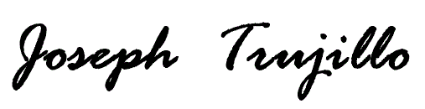
joseph.trujillo@noaa.gov
(469) 571-3061

